### To Build A Hyper-Local Weather Dashboard Using The

### Weather Company's API On IBM Cloud.

Project Report

IBM Hack Challenge 2020

Application ID: SPS_CH_APL_20200006618

Project ID:SPS_PRO_1722

Team: ARTHUR

**INDEX**

|  |  |  |  |  |  |  |  |
| --- | --- | --- | --- | --- | --- | --- | --- |
| **1** | |  | **INTRODUCTION** | |  |  |  |
|  | |  | 1.1 Overview | |  |  |  |
|  | |  | 1.2 Purpose | |  |  |  |
| **2** | |  | **LITERATURE SURVEY** | |  |  |  |
|  | |  | 2.1 Existing problem | | |  |  |
|  | |  | 2.2 Proposed solution | | |  |  |
| **3** | |  | **THEORITICAL ANALYSIS** | |  |  |  |
|  | |  | 3.1 Block diagram | |  |  |  |
|  | |  | 3.2 Hardware / Software designing | | |  |  |
| **4** | |  | **EXPERIMENTAL INVESTIGATIONS** | | |  |  |
| **5** | |  | **RESULT** |  |  |  |  |
| **6** | |  | **ADVANTAGES & DISADVANTAGES** | | |  |  |
| **7** | |  | **APPLICATIONS** | |  |  |  |
| **8** | |  | **CONCLUSION** | |  |  |  |
| **9** | |  | **FUTURE SCOPE** | | **`** |  |  |
| **10** | |  | **BIBILOGRAPHY** | |  |  |  |
|  | |  | **APPENDIX** | |  |  |  |
|  |  | |  |  |  |  |  |

**INTRODUCTION**

**1.1 Overview**

Climate change is causing farmers to reconsider the crops they grow, but they may not be aware of what crops will work well in the new circumstances, according to the changing water availability. Awareness and education of suitable crops and their needs for a good yield, will help farmers make water-friendly choices.

Learn how to build a weather dashboard using a personal weather station, Node-RED, Weather Underground, and The Weather Company APIs and the node-red-contrib-twc-weather nodes. This gives a basic idea about how to display hyper-local weather information from a residential or farming weather station.

.

**1.2 Purpose**

Experience weather visualization in virtually all your locations in one, easy-to-use weather dashboard.

Help you quickly identify actions needed in specific locations that have upcoming severe weather.

Have the ability to identify in advance new weather-driven opportunities.

Operations Dashboard will equip you with the information you need to help deliver proactive direction to leadership in individual Locations.

Help you deliver a prioritized action list for personnel at specific locations.

**LITERATURE SURVEY**

**2.1 Existing problem**

Climate change has the potential to impact every human, every industry and every living organism on the planet. It sounds extreme because it is. Exhaustive research has confirmed changing weather patterns, rapidly rising sea levels, and extreme weather events proliferating around the world. This trend will not change without action. Innovate with the latest technology to address.

Climate change is causing farmers to reconsider the crops they grow, but they may not be aware of what crops will work well in the new circumstances, according to the changing water availability. Awareness and education of suitable crops and their needs for a good yield, will help farmers make water-friendly choices.

**2.2 Proposed solution**

By using IBM Cloud, Node Red and PWS it makes the application development much easy and reduces the complexity of the application. With the help of weather dashboard data set present in underground weather site makes it easy.

**THEORITICAL ANALYSIS**

**3.1 Block diagram/Flow chart**

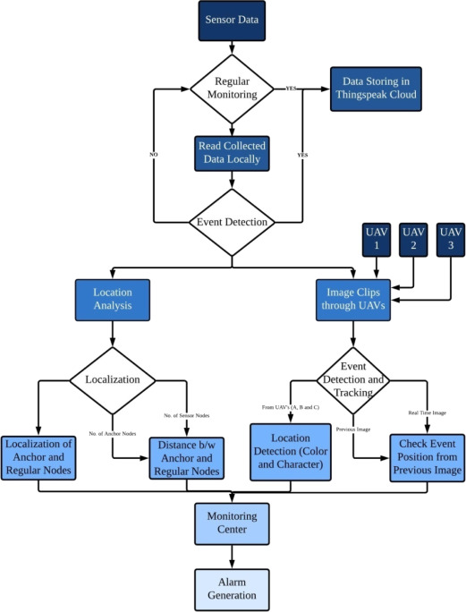

**3.2 Hardware / Software designing**

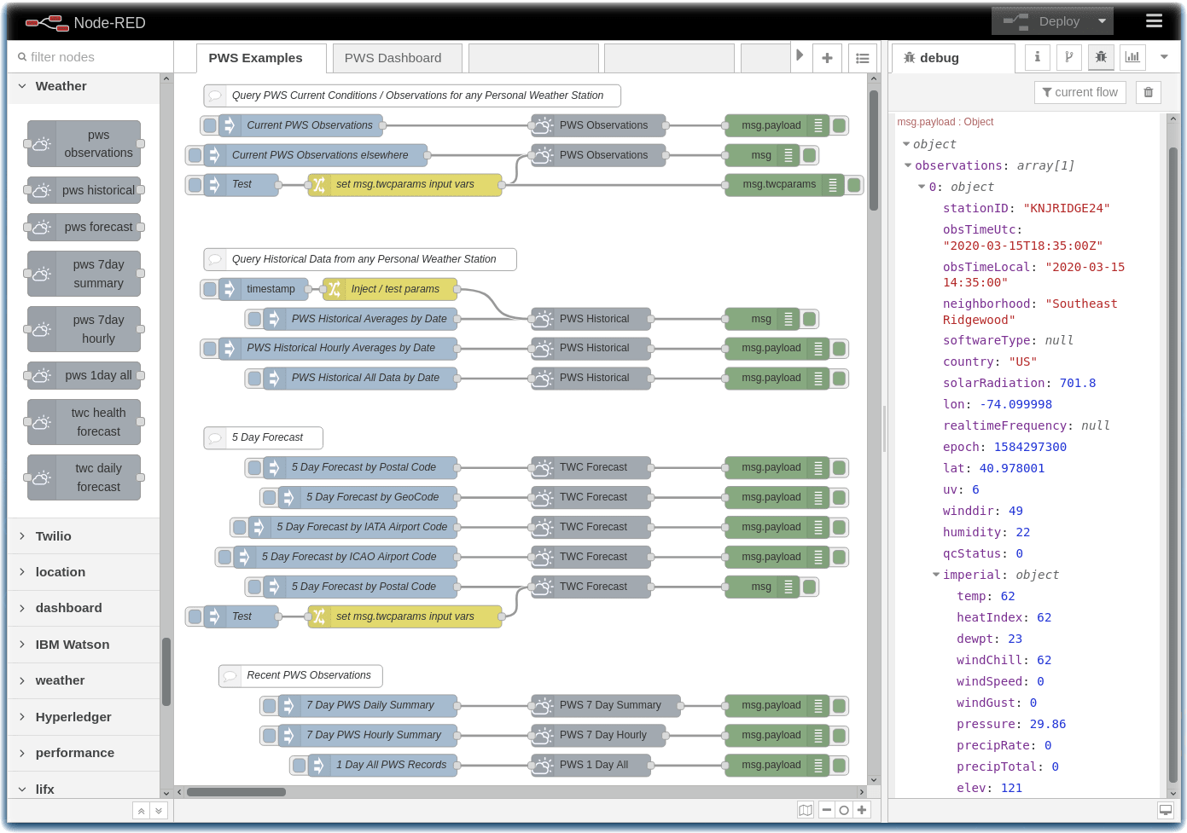

**EXPERIMENTAL INVESTIGATIONS**

In this process of developing the project I have undergone many investigation processes to learn and understand new concepts so that I can build the news search application successfully. For I had to learn and investigate following:

* IBM Cloud.
* Node Red.
* .Weather Underground
* The Weather Company APIs
* the node-red-contrib-twc-weather nodes

**RESULT**

**Interface: Display PWS Data In Your Weather Dashboard**

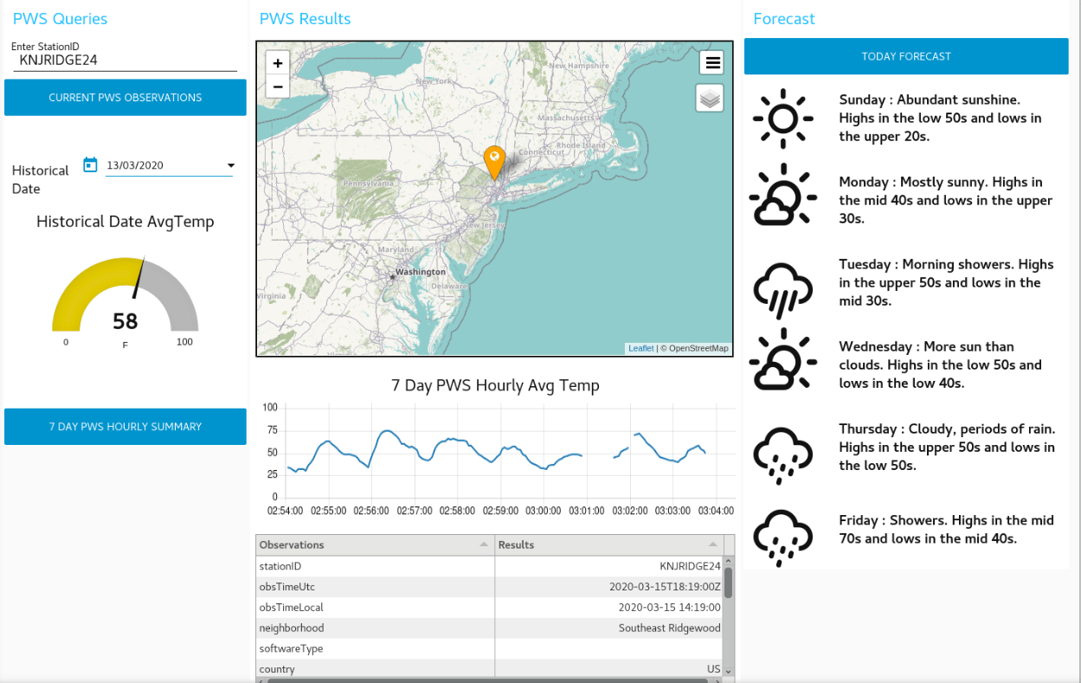

**ADVANTAGES**

The Hyper-Local Weather Dashboard includes following advantages:

* Easy to create.
* Less time required to develop.
* High performance with IBM cloud.

**DISADVANTAGES:**

The Hyper-Local Weather Dashboard following disadvantages:

* We need to pay for IBM platform service.
* The services which we use require amount for space we use.
* The data provided by the Weather Station is for a limited period of time .

**APPLICATIONS**

### Current weather visualization

A highlight of the dashboard includes visualization of the current weather and short-term forecast for each specific location identified. The user can customize parameters, thresholds and calls to action. Near real-time and forecasted location-specific weather and traffic views optimize the data provided by some of the most advanced tools in the industry.

### Near real-time weather alerts upon reaching preset threshold

Weighted weather alerts allow prioritization of the most critical forecast updates. Value thresholds and calls to action can be easily customized for your business needs.

### More accurate predictions can lead to better decisions

The Operations Dashboard provides insight regarding the approaching weather via alerts as well as associated videos that offer more detailed information. Help proactively monitor weather and aggregate data for all locations in one place. Trigger alerts to help you make more-informed decisions.

### Intuitive weather dashboard

A streamlined weather dashboard with visualization that combines the forecast, client locations and/or traffic and other data to reveal insights that could impact operations. This tool is available through browsers, iOS and Android devices.

**CONCLUSION**

This project gave you some basic working knowledge of the IBM Cloud Service and shows how to use it along with JavaScript and Node Red to build your own Hyper-Local Weather Dashboard . This project also tells about the integration process of PWS with the Watson services to access and create your weather dashboard.

**FUTURE SCOPE**

**Through this it helps to improve the response time**

.Based on information within the Operations Dashboard, we can determine the safety actions to employ in specific locations due to severe weather, such as tornadoes or lightning at sporting events.

**Optimize weather-driven opportunities**

Knowing weather forecasts in advance may present business opportunities for increased sales of specific products or services. we can use this data to entice customers with proactive communications.

**BIBILOGRAPHY**

**Name**: RUPAL RAJ

**College Name**: KALINGA INSTITUTE OF INDUSTRIAL TECHNOLOGY.

**Work Title:** Hyper-local weather dashboard using The Weather company's API on IBM Cloud.

**References:**

1. IBM Cloud: <https://www.ibm.com/cloud/get-started>
2. Node red tutorial: <https://developer.ibm.com/tutorials/how-to-create-a-node-red-starter-application/>
3. About API:<https://www.wunderground.com/member/api-keys>
4. node-red-contrib-web-worldmap:<https://flows.nodered.org/node/node-red-contrib-web-worldmap>

**APPENDIX**

**Link to Node Red work space:**

[node-red-contrib-twc-weather](https://flows.nodered.org/node/node-red-contrib-twc-weather)

[node-red-dashboard](https://flows.nodered.org/node/node-red-dashboard)

[node-red-node-ui-table](https://flows.nodered.org/node/node-red-node-ui-table)

[node-red-contrib-web-worldmap](https://flows.nodered.org/node/node-red-contrib-web-worldmap)

**Link to Weather station :** <https://www.wunderground.com/member/api-keys>